Metal Frame Build for the Maslow M2
I got the idea from here: https://forums.maslowcnc.com/t/unistrut-frame-designs/1267/23?fbclid=IwAR187iMNACdftz2aNFXKME4u7fI2C4Qie432oEuSLJwLOJ6KpUWlq62JJCI

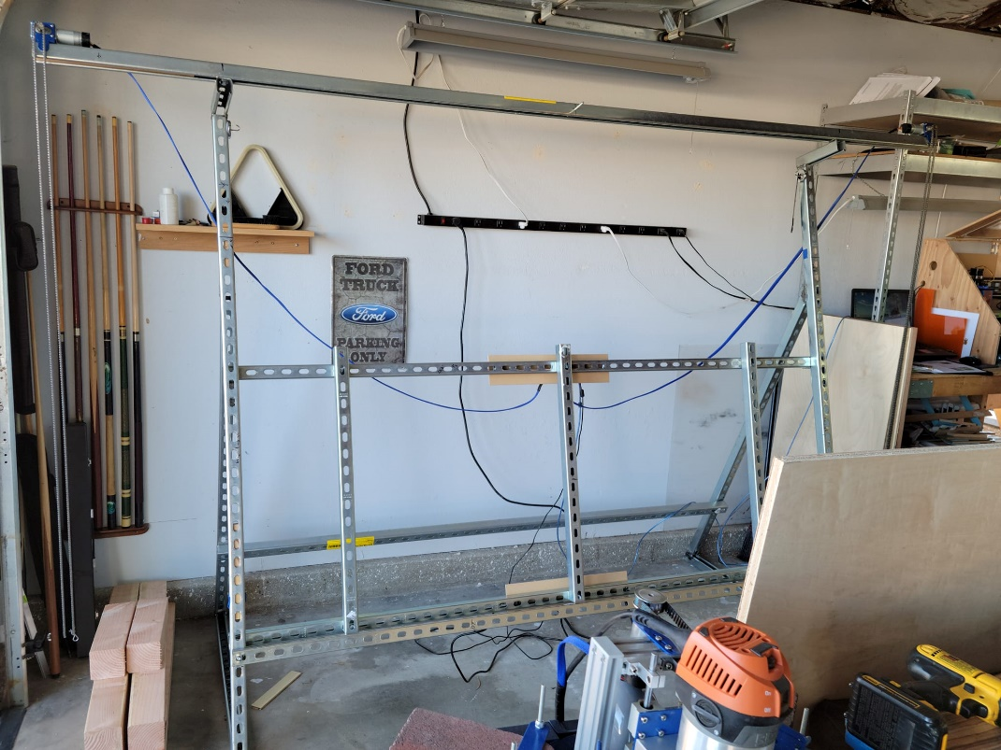

Basic Material List:
(If you do not want to weld the legs, you will need to get L brackets and additional bolts, washers, and channel spring nuts)
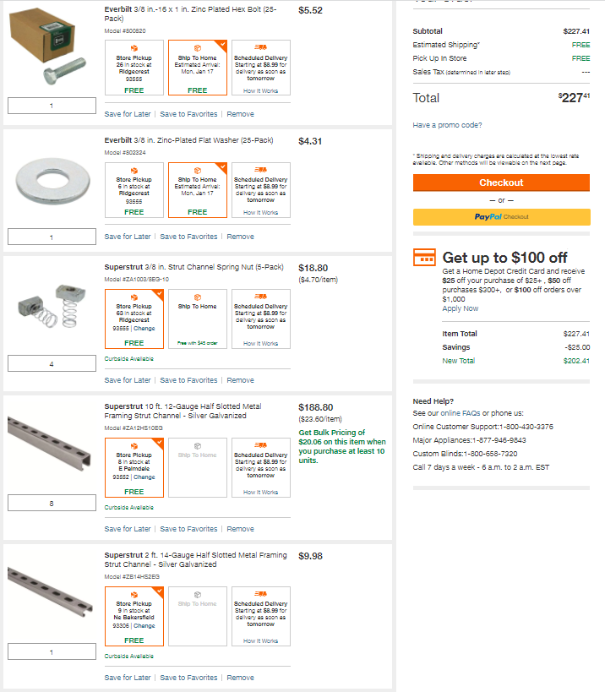

Step 1 – Cut Superstrut /Unistrut
(1) 10ft – for top beam
(2) 74 inch – for front legs
(2) 60 inch – for back legs
(2) 36 inch – for bottom of legs
(3) 86 inch – for horizontal support pieces (one in middle of front leg, one for middle of back leg,
and one goes on the inside of the front leg about 1ft up from ground).
(3) 34 inch – middle supports
(2) 8 inch – for top beam support
(1) 86 inch – this is the half slotted one to hold waste board. (Or you can just use the full size
one)
(So, you will need a total of about (9) 10-foot pieces of Unistrut)

Building the Frame
Right and Left Sides:

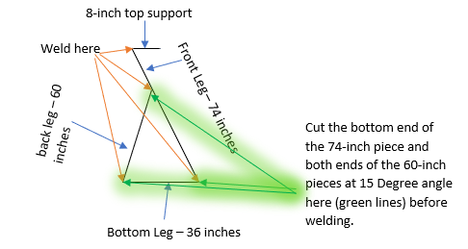

Add the 86 inch Supports to frame:
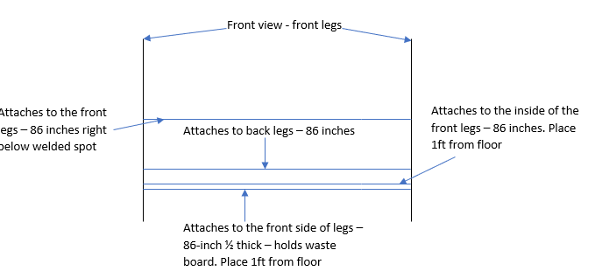
Attach the supports using 8 bolts, 8 spring nuts, and 8 washers

Add the Top Unistrut:

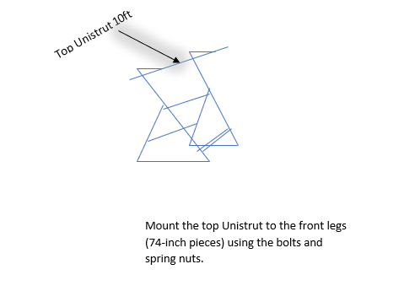
Attach the top Unistrut using 2 bolts, 2 spring nuts, and 2 washers

Add Center Supports:
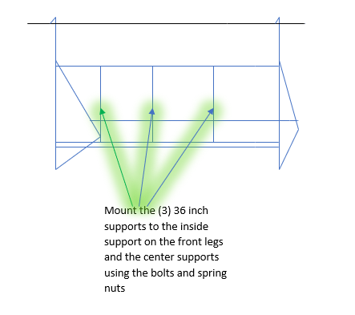
Attach the center support Unistrut’s using 6 bolts, 6 spring nuts, and 6 washers

Finishing up:
After making sure everything is tight and there is little to no movement in the frame then add the waste board, chains, sled, electronics, etc. as directed in the Maslow guide.

